Crime Management System

Regno: 16BCE0526

Name: Nitish Surana

Slot: L57+L58

Course: Software Engineering

Course code: CSE3001

Mail id: surananitish@gmail.com

Phone number: +91 7530000524

Project management plan document

Index

|  |  |
| --- | --- |
| Content | Page no |
| Abstract | 2 |
| Introduction | 2 |
| List of Stakeholders and User stories | 3-4 |
| Process Model and Justification | 4 |
| Work Breakdown Structure | 5 |
| Table of Milestones and Deliverables | 5-6 |
| Activity Dependancy Table | 6 |
| Project Schedule | 7-8 |
| Risk Management | 8 |
| Appendix | 8-9 |

Abstract

The present world is technology driven as it is employed by many fields in the performance of their operation. In the case of law enforcement agencies, it is required to have a solid Crime management system to safeguard the rights of people and to maintain law and order in the country. Crime being an act against the law of a society is a threat to the well-being of the populace and so, requires efficient and effective monitoring. For this reason, Crime Management System has been developed to achieve this purpose.

Introduction

Aim and objective of the project: -

Crime Management model requires a solid foundation of laws which should not be changed and are needed while making a software model. These laws ensure the law and order over the country and safeguard the rights of the citizens and also maintain the proper functioning at various workplaces. If these laws are bent or changed during its functioning it will lose its significant importance and will gradually increase the number of crimes all-round the country. These laws should not be changed. Hence the aim of the project is creating the Crime Management System.

Scope of the project: -

Since while making of the above-mentioned project, various steps are involved which including Making of SRS Document, SDS Document along with Testing and Verification the output of the project can be used by any industrial professional to develop the software for the respective system as all the major documents that are required for developing the software are made. Hence, this project can be used by industrial professionals to implement this possible software system on a real-life scale.

List of stakeholders and user stories

|  |  |  |
| --- | --- | --- |
| Sr.no | Stakeholder | Uses |
| 1. | Police Department | * To spread maintain the law and order. * To ensure the security of the people. * To give a judicious system that provides chance to non-guilty people to prove their innocence. |
| 2. | Cyber administrator | * To avoid online harassment. * To avoid multiplication of copyright data. * To avoid unauthorized access to data. |
| 3. | Officers Present at airport | * To avoid the unauthorized entry of non-native people. * To ensure that no harmful products are brought by passengers that can cause harm during travel. * To avoid passengers with non-VISA/ expired VISA to pass when the passengers is travelling from one country to another. |
| 4. | Colleges | * Safety of students from physical/mental violence. * To provide a non-harmful environment for student. |
| 5. | Judges at various courts | * To ensure that guilty persons are giving punishment accordingly. * To maintain law and order in the country. |
| 6. | Artists | * To avoid copyright of their data. * To ensure that their data is not released without their confirmation. * To ensure that the guilty person responsible for their data loss has punished and fined accordingly. |
| 7. | Jobs/Workplaces | * To ensure that the employee working in the particular job restrains from sharing data with other person working for different company. (Affidavit). * To ensure proper working of employees under their seniors. * Security of employees. |
| 8. | Tourist Places | * To avoid the damage to various monuments. * To preserve the historical decency of the country. |

Process model and justification

The model for this project is the **Waterfall Model**. This model follows a sequential order which ensures that a phase is completed before another phase begins. This system model emphasizes planning in early stages, is used in projects where all the system requirements are known and in addition, its intensive documentation and planning make it work well in which quality control is a major concern.

Crime management system involves its requirements easily understandable before creating the software model. The requirements should be clear, complete and be well defined in the early stages of creating the model implemented. Since process models like Prototyping model, Spiral Model, Iterative model, Evolutionary model do not follow these above-mentioned points involving the requirements, these models cannot be used to implement the Crime Management system.

Crime management should not have any changes done in the further stages of processing (example Coding, Testing) which are might affect previous stages on which the foundation of the process model was built (example Analysis). This signifies that the process model that is chosen should not have any iterative phase. Since process models like Prototyping model, Iterative model, Spiral model and Concurrent Development involves having an iterative phase, these models cannot be taken to represent the Crime Management System.

Work breakdown structure

* Requirements Phase
* Gather All the Requirements.
* Determination of Specific Requirements.
* Develop the Details of The System
* Develop the SRS Document.
* Design Phase
* Develop the SDS Document.
* Implementation Phase
* Creating the list of Laws and Regulations required.
* Creating the list of Criminals along with the respective count of police officers at each police department.
* Front end Database.
* Testing Phase
* Testing and Verification
* Maintenance Phase
* Corrective Maintenance

Table of milestones and deliverables

Milestones: -

* Gather all the Requirements.
* Determination of specific requirements.
* Develop details of the system.
* Development of SRS document.
* Development of SDS document.
* Implementation.
* Create the Test Plan
* Testing and Verification
* Corrective Maintenance

Deliverables: -

* Generation of the SRS Document.
* Generation of the SDS Document.
* Output of the Implementation Phase.
* Testing and Verification.

Activity dependency table

|  |  |  |  |  |
| --- | --- | --- | --- | --- |
| Task | Label | Predecessor | Staff Required | Estimation duration |
| Gather all the Requirements | A | - | 5 | 7 |
| Determination of specific requirements | B | A | 3 | 3 |
| Develop details of the system | C | B | 3 | 3 |
| Development of SRS document | D | C | 6 | 9 |
| Development of SDS document | E | D | 6 | 15 |
| Implementation | F | E | 6 | 7 |
| Create the Test Plan | G | F | 4 | 5 |
| Testing and Verification | H | G | 5 | 3 |
| Corrective Maintenance | I | H | 4 | 5 |

Project schedule

* Gantt chart –process model: -

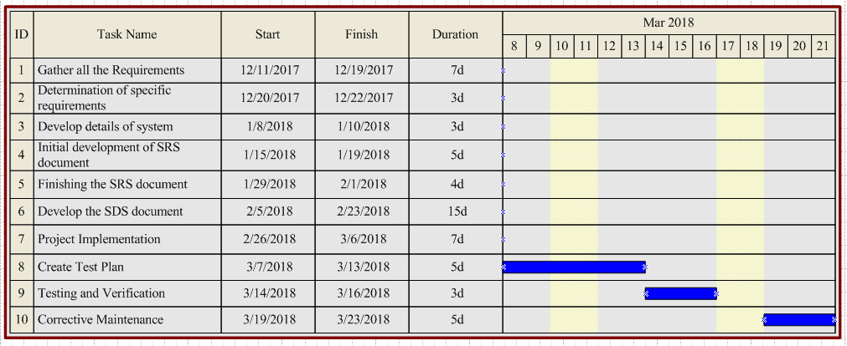

* Gantt chart- implementation: -

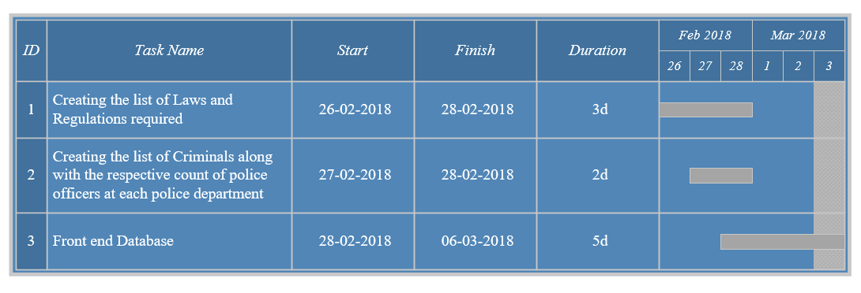

* Activity network

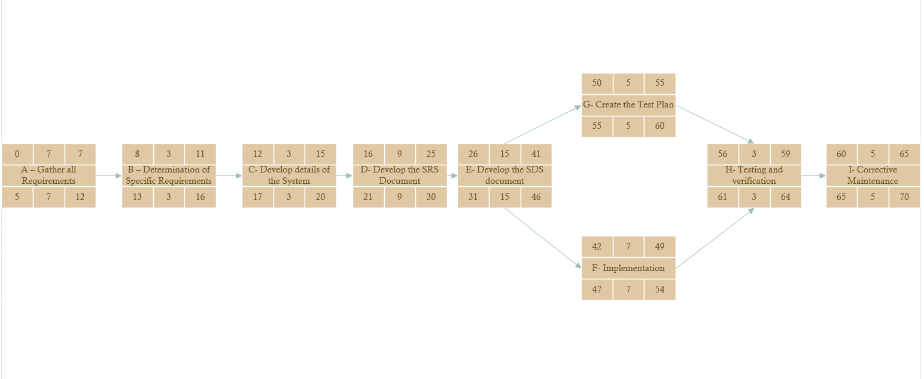

* Timeline chart

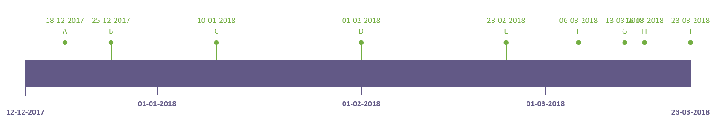

Where A- Gather all the Requirements,

B- Determination of Specific Requirements,

C- Developing the details of the System,

D- Developing the SRS Document,

E- Developing the SDS Document,

F- Project Implementation,

G- Creating the Test plan,

H- Testing and Verification,

I- Supportive Maintenance.

Risk Management

|  |  |  |
| --- | --- | --- |
| Risk | Probability | Effect |
| Medical sickness. | Low | Low |
| Change in Requirements risk. | Low | Medium |
| Wrong methodology used to implement the required tasks. | Low | Medium |
| Loss of data while making the documents. | Low | Medium |
| Not following the schedule planned for execution of the project. | Low | Severe |

Appendix

* Stakeholder: - A person, group, or organization that is actively involved in a project, is affected by its outcome, or can influence its outcome.
* Milestones: - Milestones are tools used in project management to mark specific points along a project timeline. These points may signal anchors such as a project start and end date, a need for external review or input and budget checks, among others.
* Deliverable: - A deliverable is a tangible or intangible good or service produced as a result of a project that is intended to be delivered to a customer (either internal or external).
* Gantt Chart: - A Gantt chart is a type of bar chart that illustrates a project schedule. Gantt charts illustrate the start and finish dates of the terminal elements and summary elements of a project. Terminal elements and summary elements constitute the work breakdown structure of the project.
* Activity Network: - An activity network diagram tool is used extensively in project management and is necessary for the identification of a project's critical path (which is used to determine the expected completion time of the project).